**Leader Overview**

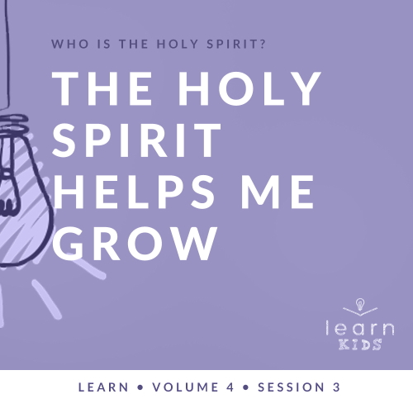

**Volume Overview**

**Who is the Holy Spirit?**

*In His most famous sermon (*[*Matthew 5–7*](https://ref.ly/logosref/Bible.Mt5-7)*), Jesus taught us to love our enemies, give to the needy, and put God’s kingdom first in our life. These high expectations don’t take us long to recognize a problem. We simply can’t do this on our own. So, why did Jesus command us to live a life He knows full well we cannot live on our own? The key is that Jesus never asked us to live the Christian life on our own. In fact, Jesus explained there is a gift that is indispensable for every Christian: the Holy Spirit. Jesus as God in the flesh is a wonderful gift, and God living inside us is amazing too! God living within us can empower us, help us grow, and equip us in a unique way that God among us could not*.

**Session Overview**

**The Holy Spirit Helps Me Grow**

*Tabitha, also known as Dorcas, lived a life that modeled the fruit of the Spirit to others. When she died, it was clear that she had made a big impact on the people in her community. When we allow God to do something significant in us, to grow us into the kind of person He desires us to be, He can then use us in greater ways to advance His kingdom*.

**Bible Lesson**

Tabitha Shows the Fruit of the Spirit

[Acts 9:36–42](https://ref.ly/logosref/Bible.Ac9.36-42); [Galatians 5:22–23](https://ref.ly/logosref/Bible.Ga5.22-23)

**Faith Fact**

The Holy Spirit helps me.

**Faith Verse**

[Galatians 5:22–23](https://ref.ly/logosref/Bible.Ga5.22-23) (NLT)

The Holy Spirit produces this kind of fruit in our lives: love, joy, peace, patience, kindness, goodness, faithfulness, gentleness, and self-control.

**Preparing for the Session**

**Leader Preparation Time: 20–25 Minutes**

|  |
| --- |
| ***You Will Need***  ***Large Group***   * *Bible* * *Worship songs (Song suggestions: “Holy Spirit” by Kari Jobe; “Set a Fire” by Jesus Culture; “Come Holy Spirit” by Vertical Worship; “Zeal” by The Belonging Co)* * *For groups not using a phone or tablet only, add:*   *• Projector or TV*  *• Laptop*  *•* ***Faith Fact Slide***  *•* ***Faith Verse Video*** *or* ***Slide***  *•* ***Bible Lesson Video***  *•* ***Teaching Point Slides 1–3***  *•* ***Large Group Game Pages****, pages 1 & 2*  *• Card stock*  *• Tape*  *• Scissors*  *• Table*  *• Bag of apples*  *• Two additional kinds of fruit that grows on trees*  *• One piece of rotten fruit that grows on trees*  ***Small Group***   * *Chairs, one per kid minus one* * *Bibles for kids in your group to share* * ***Small Group Faith Verse Review****, one set per group* * *Scissors* * ***Small Group Activity Page****, one per kid* * *Pencils or pens, one per kid* * *Crayons*   *To access session content and videos from a computer, visit:* [*BibleEngagementProject.com/downloads*](https://bibleengagementproject.com/downloads) |
| ***Getting Ready***  ***Large Group***   * *Download videos and slides if needed.* * *Select worship song(s) and have them ready to play.* * *Read the Bible Lesson Scripture to prepare for teaching time.* * *Print the* ***Large Group Game Page****, two or more sets, on card stock. (If your group is smaller, only use a few sets of the fruit of the Spirit cards so at least two kids have the same card. If your group is larger, you’ll need extra sets. Be sure not to use cards that don’t have a match.)* * *Cut apart the cards.*   ***Small Group***   * *Set up the chairs in a circle with some distance between each chair.* * *Print the* ***Small Group Faith Verse Review****, one set per group.* * *Cut apart the slips.* * *Print copies of the* ***Small Group Activity Page****, one per kid.*   ***First time leading* Learn *for Kids? Check out the*** [***Facilitator Guide***](https://0b769b0ed3569ef9d18b-f88d8272f61086866d50d048b43ef630.ssl.cf2.rackcdn.com/sites/biblengagementproject/Listen_Facilitator_Guide.pdf)***.*** |

**Large Group**

**30 Minutes**

*See what’s needed at the beginning of the session.*

**Introduction**

Welcome, everyone! Are you ready to learn more about the Holy Spirit? *(Group response)* Today, we’ll continue to answer the big question: Who is the Holy Spirit? We know that the Holy Spirit is God and that He empowers us to do amazing things. Did you know that the Holy Spirit is sometimes described as the Helper?

You might be used to hearing the word *helper* when your parents say, “Be a helper and clean up this mess.” Well, the Holy Spirit is here to help us, but in different ways. He helps direct us away from sin. He also helps us become more like Jesus.

**Faith Fact**

Raise your hand if you could use the Holy Spirit’s help. *(Group response)* We should all have our hands up. Our Faith Fact says that. **The Holy Spirit helps me**. Let’s say it together. *(Group response)*

• *Show the* ***Faith Fact Slide***.

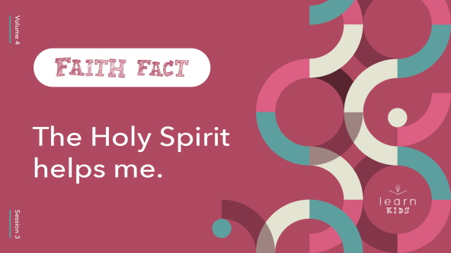

Can you say that with me one more time? 1, 2, 3. **The Holy Spirit helps me**. Great job! We can all use His help, so I’m glad the Holy Spirit is always around to help us.

**Game**

**Find Your Match**

|  |
| --- |
| ***You Will Need***   * ***Large Group Game Pages****, pages 1 & 2* * *Card stock* * *Tape* * *Scissors*   ***Getting Ready***   * *Print the* ***Large Group Game Page****, two or more sets, on card stock. (If your group is smaller, only use a few sets of the fruit of the Spirit cards so at least two kids have the same card. If your group is larger, you’ll need extra sets. Be sure not to use cards that don’t have a match.)* * *Cut apart the cards.* |

For our game, we’ll help each other and work together to find our match. This will remind us that the Holy Spirit helps us. I’ll tape a fruit of the Spirit card on each person’s back without showing it to you.

• *Have kids stand around the edge of the room, so they can’t see anyone’s back*.

• *Tape a card to each kid’s back*.

Your friends will see the card you have, but you won’t know what it is. Without talking, you’ll help each other figure out what everyone has. Then, you’ll match up with the other kids who have the same fruit of the Spirit card. Try to be the first to gather everyone with the same fruit together.

Ready to play? Let’s see how quickly you can help each other find your matches. When you find someone who matches with you, stick together.

• *The game is over when everyone finds their match*.

Great job! You worked together and helped each other so well.

**Worship**

It’s time to worship God and thank Him for all He does for us! Stand up and let’s worship by singing!

• *Lead the kids in singing one or two praise songs. See suggestions at the beginning of the session*.

**Bible Lesson**

Let’s learn even more about the Holy Spirit and how He helps us. One of the best things we can do right now is to stop, pray, and ask for the Holy Spirit to help us. He’ll guide us and teach us new things when we ask for His help. Let’s pray and ask Him for help right now.

**Prayer**

|  |
| --- |
| *Father God, help us through Your Holy Spirit to have open ears and an open heart to learn something new about You. Help us to grow in the fruit of the Spirit and know You more. Amen.* |

**Video Intro**

Before we look at the Bible story, let’s watch this video.

• *Play* ***Bible Lesson Video***.



**Bible Story**

**Tabitha Shows the Fruit of the Spirit**

That video was such a fun lead-in to our Bible story today. Can you think of people who obviously have the fruit of the Spirit growing in their life? Maybe they love everyone or are always full of joy. Maybe they have peace even in the middle of a difficult situation. Raise your hand if someone comes to mind. *(Group response)*

Well, today’s Bible story is about someone like that. Her name is Tabitha, or she’s also called Dorcas. Tabitha had the fruit of the Spirit in her life that others could see. Let’s find out more about Tabitha. If you want to follow along, open your Bible to [Acts 9:36–42](https://ref.ly/logosref/Bible.Ac9.36-42).

• *Read the Bible story aloud to the group*.

• *In order to keep Large Group time moving along, we don’t recommend having the kids read*.

• *Optional: Remind the kids to mark this place with their Bible Bookmark, so they can read it on their own at home*.

**Teaching Time**

|  |
| --- |
| ***You Will Need***   * *Table* * *Bag of apples* * *Two additional kinds of fruit that grows on trees* * *One piece of rotten fruit that grows on trees*   *No prep needed for this activity.* |

Isn’t it crazy that Tabitha died even though she was blessing others? *(Group response)* It’s amazing that when Peter prayed for her, she came back to life. Would you like to have been there when that happened? *(Group response)* That was a rare miracle even for the Bible. God may have allowed it to happen because He saw the kind of person Tabitha was. She was loved by many, and she had the fruit of the Spirit growing in her life. Let’s see what we can learn from that.

**1. The Holy Spirit helps us grow in character**.

• *Show the* ***Teaching Point 1 Slide***.

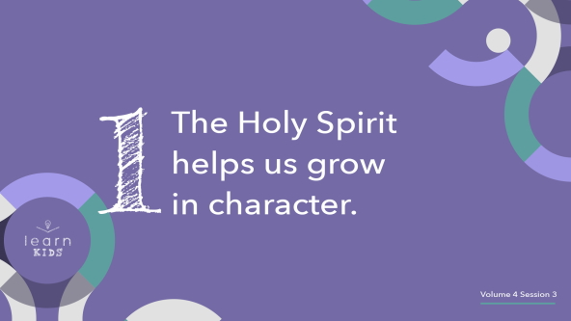

The Holy Spirit wants to help us grow to become more like Jesus. That should be our ultimate goal in life. What are some things you can remember about Jesus’ character, which is how He acted or behaved? *(Allow responses.)* Jesus was an incredible example of having the fruit of the Spirit in His life. Let’s see if we can name all the parts of the fruit of the Spirit. *(Love, joy, peace, patience, kindness, goodness, faithfulness, gentleness, and self-control)*

Now did Jesus just have just one or two parts of the fruit of the Spirit in His life? *(Group response)* Of course not! You could see all of them growing in His life. That’s what our life should be like. I think that’s one of the reasons Jesus sent the Holy Spirit to us. He knew we’d need help growing the fruit of the Holy Spirit in our life.

Let me see if I can explain this a little more. When you think of a fruit tree, what do you think of? *(Allow responses.)*

• *Hold up the fruit while you talk about fruit trees*.

Typically, a fruit tree will only grow one kind of fruit. That’s why we usually don’t call them fruit trees. We call them apple trees, orange trees, and peach trees for example.

I’m glad the Holy Spirit can help us grow every part of the fruit of the Spirit, not just one. What a relief! We don’t have to pick and choose because God wants to grow all parts of the fruit in our life. We should have all of it growing in our life. We need it all, too. We need love, joy, peace, patience, kindness, goodness, faithfulness, gentleness, and self-control. Each of these parts goes together into one fruit that the Holy Spirit grows in us. We can’t just throw away the part we don’t want or like.

**2. What the Holy Spirit grows on the inside will show on the outside**.

• *Show the* ***Teaching Point 2 Slide***.

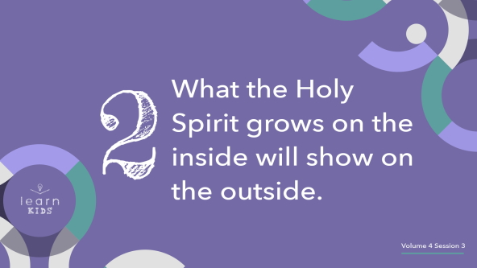

How can we know that Tabitha had the fruit of the Spirit growing inside her? *(Allow responses.)* The Bible tells us she helped poor people and did kind things for others. That sounds like kindness and goodness to me. Those acts may have come from the love she felt toward others. All of those are parts of the fruit of the Spirit. It must have been obvious through the way she acted and what people knew about her that the fruit of the Spirit was growing in her life. We also know that she was a believer because the other Christians sent for Peter to come when she died.

• *Hold up an apple while you talk*.

If a fruit tree is healthy and growing, what will happen*? (Allow responses.)* The tree will produce good, healthy, yummy fruit.

• *Bite into the apple and eat it, making a big deal about how yummy it is*.

In the same way, when the Holy Spirit is working in our life, people will be able to see the evidence of His work in the way we choose to live. What about if a tree is unhealthy? What happens to the fruit? *(Allow responses.)*

• *Hold up the piece of rotten fruit*.

It will probably have rotten fruit hanging from its branches or on the ground below it. Eventually, the tree may stop producing fruit altogether, shrivel up, and die. We don’t want that to be what our life looks like. That’s why we need the Holy Spirit’s help. We need to allow the Holy Spirit to grow His fruit in our life.

Everything we do to give God control of our life helps the fruit grow. That’s because we don’t grow the fruit—the Holy Spirit grows it. Reading the Bible, spending time in prayer, listening to God, and following the Holy Spirit’s guidance puts God in charge. When we do those things, we’re making ourself ready for Him to make us grow.

**3. The Holy Spirit works in you so He can do more through you**.

• *Show the* ***Teaching Point 3 Slide***.

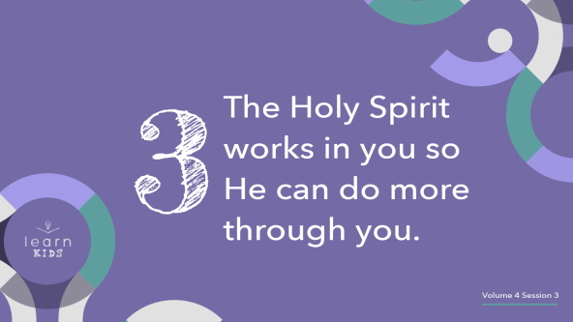

The more we allow the Holy Spirit to work in us, the more we reflect who Jesus is to the people around us. We must let the Holy Spirit do His work in us so He can use us in greater ways to make a difference in the world.

Because Tabitha allowed the fruit of the Spirit to grow in her life, she made such a difference that even in her death she affected so many people. God decided that He wasn’t done working through her, so He allowed Peter to pray for her before raising her back to life. Now, raising a dead person back to life is not a common thing for God to do, but it’s a great example of how God wanted to work through her to do even more good for others.

God wants to do the same thing with us. We need to allow the Holy Spirit to work inside us and grow us so we can do more for Him.

Back to the fruit trees one more time. If a tree is healthy, what will happen with time? *(Allow responses.)*

• *Hold up the bag of apples while you talk*.

The tree will continue to grow bigger, and the tree will produce even more healthy fruit. As we continue to grow as Christians and allow the fruit of the Spirit to grow inside us, the Holy Spirit will work through us to produce even more fruit. That means that we will influence even more people in a positive way and point even more of them to Jesus.

**Prayer and Response**

*Consider playing a worship song softly in the background while kids pray*.

How many of you would like to be used by the Holy Spirit to do awesome things? Raise your hand. *(Group response)* That’s great! Me, too! It starts with allowing the Holy Spirit to help us grow on the inside. If the fruit of the Spirit is growing inside you, it will be obvious to others by the things you say and do.

Maybe there are some things you need to stop saying and doing so that you can allow the Holy Spirit to work through you. Let’s take a moment to pray. Allow the Holy Spirit to help you by showing you what you need to change or get rid of in your life. Then, you can continue to grow and produce good fruit. First, let’s sit quietly for a minute while we listen for the Holy Spirit to speak to us. Then, I’ll pray.

• *Pause while kids listen for the Holy Spirit to speak*.

**Prayer**

• *Optional: Have the kids repeat phrases of the prayer after you*.

|  |
| --- |
| Dear God, help us to see areas in our life where we fall short and miss the mark. Help us to focus on You and try to be more like You. Help us to grow in the fruit of the Spirit so that other people can come to know Jesus through our actions. Amen. |

**Faith Verse**

We’ve been learning about the fruit of the Spirit, so let’s say our Faith Verse together.

• *Play* ***Faith Verse Video***.

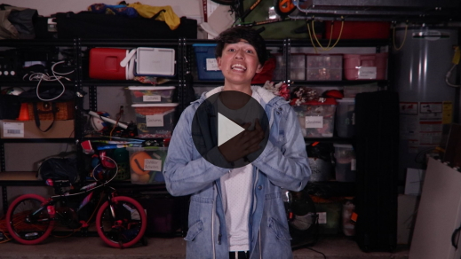

[Galatians 5:22–23](https://ref.ly/logosref/Bible.Ga5.22-23) (NLT)

The Holy Spirit produces this kind of fruit in our lives: love, joy, peace, patience, kindness, goodness, faithfulness, gentleness, and self-control.

Each part of the fruit of the Spirit helps us live a godly life so others can see the Holy Spirit is living inside us. That will make people want what we have in their life, too.

**Faith Fact**

Before we go to our small groups, let’s review our Faith Fact again.

• *Show the* ***Faith Fact Slide***.



Say it with me**. The Holy Spirit helps me**. Who’s thankful for the Holy Spirit’s help in your life? *(Group response)* Remember to ask Him for help anytime you need it.

• *Dismiss kids to Small Group time or to go home if your group time ends here*.

**Small Group**

**30 Minutes**

*This section can be done in conjunction with the large group or on its own if you do small groups with your kids. During Small Group time, the goal is to connect the kids with the Word of God and to each other. All activities are led by the small group leader.*

**Group Connection**

**Fruit Mash-Up**

|  |
| --- |
| ***You Will Need***   * *Chairs, one per kid minus one*   ***Getting Ready***   * *Set up the chairs in a circle with some distance between each chair.* |

Who thinks they have all nine parts of the fruit of the Spirit memorized already? *(Allow responses.)*

• *Choose one kid who their raised their hand to list the fruit of the Spirit. Add any they missed if necessary*.

Let’s say all the parts of the fruit of the Spirit together a couple times before we play a game using the fruit of the Spirit.

• *Lead the kids in saying all nine parts of the fruit of the Spirit: love, joy, peace, patience, kindness, goodness, faithfulness, gentleness, and self-control*.

Great job! I’m going to assign each of you a part of the fruit of the Spirit by whispering it in your ear. Don’t forget it! Then, find a seat.

• *Make sure at least two kids have the same part of the fruit of the Spirit even if you don’t use all of them. For example, if you only have six kids, only use love, joy, and peace*.

• *Let the person who’s still standing know that they’ll start the game*.

When you’re in the center of the circle, call out one part of the fruit of the Spirit. Anyone who was assigned that part of the fruit of the Spirit must jump up and find a different seat. The person in the center will attempt get to a seat, too. Whoever is left standing without a seat will be in the center for the next round. Got it? *(Group response)*

There’s one more rule. If the person in the middle says, “Fruit mash-up,” then everyone moves to a new seat. Are you ready to play? *(Group response)*

• *Continue playing until you run out of time*.

**Learn about It**

|  |
| --- |
| ***You Will Need***   * *Bibles for kids in your group to share*   *No prep needed for this activity.* |

**Scripture Search:** [**Galatians 5:22–23**](https://ref.ly/logosref/Bible.Ga5.22-23)**;** [**1 John 4:16**](https://ref.ly/logosref/Bible.1Jn4.16)**;** [**John 13:34–35**](https://ref.ly/logosref/Bible.Jn13.34-35)**;** [**1 Corinthians 13:4–7**](https://ref.ly/logosref/Bible.1Co13.4-7)

Let’s dig deeper into God’s Word and see what else He has to say about the fruit of the Spirit. As we read each of these verses, let’s consider: What does this Scripture mean for our life today?

• *Give each kid a Bible and search for one or more of the Scriptures as a group together (as time allows). When everyone has found the Scripture, have one of the kids read it. Then, answer the questions about it*.

• *Pair kids who need additional help with older kids or start simple and look up the session’s Bible story Scripture:* [*Acts 9:36–42*](https://ref.ly/logosref/Bible.Ac9.36-42)*. Kids will get better at finding Scriptures the more they practice*.

• *Optional: Make this a competition to see who can find the Scripture first*.

**Bible Reading Tip**

It’s easy to slip into the habit of reading your Bible to check it off your to-do list or to tell your parents that you read it. Instead take the time to make reading God’s Word valuable and worthwhile. Ask the Holy Spirit to help you grow while you read. Remember, the Bible isn‘t like other books. It’s God’s Living Word. That means God can use His Word to speak new things to you every time you read it, but you have to be ready to listen.

**Challenge**

This week focus on one part of the fruit of the Spirit from our Faith Verse and try to really make sure you are living it in front of others. For example, if you focus on being patient, try to pay attention to all the times you are acting patiently. If you want to focus on being kind, try to notice how many times you say something kind to someone.

**Faith Fact**

This challenge might not be easy, but I’ve got good news. Our Faith Fact reminds us that we’re not doing this alone. Say it with me: **The Holy Spirit helps me**.

**Group Discussion**

*Feel free to use all or just a few questions as a jumping-off place for good discussion. Questions marked with * are designed for more conversation. Adjust the questions based on the age or maturity of your group. Typically, older kids will be able to dive a little deeper than younger ones*.

**Questions**

• *If small group activities are not immediately following large group time, you may want to read the Bible story passage before this discussion*.

What was Tabitha’s other name?

What do we know about Tabitha based on this Scripture passage?

What happened to Tabitha that made everyone sad?

Who did the believers call to come to them?

What happened when Peter prayed for Tabitha?

* How are you helpful to your parents?

* How are you helpful to your friends?

* How does the Holy Spirit help you?

* Do you feel like you are growing the fruit of the Spirit in your life? Why or why not?

* What part of the fruit is the Holy Spirit helping to grow in you in the last couple of weeks?

**Prayer Requests**

*Finish group discussion by sharing prayer requests and praise reports. Keep track of your small group’s prayer requests and review them each time you meet*.

**Prayer**

*Have kids pray for each other’s prayer requests*.

**Faith Verse Review**

|  |
| --- |
| ***You Will Need***   * ***Small Group Faith Verse Review*** * *Scissors*   ***Getting Ready***   * *Print the* ***Small Group Faith Verse Review****, one set per group.* |

Our Faith Verse is [Galatians 5:22–23](https://ref.ly/logosref/Bible.Ga5.22-23). It names the fruit the Holy Spirit helps us grow in our life. Let’s watch the Faith Verse video and do the actions for the verse together.

[Galatians 5:22–23](https://ref.ly/logosref/Bible.Ga5.22-23) (NLT)

The Holy Spirit produces this kind of fruit in our lives: love, joy, peace, patience, kindness, goodness, faithfulness, gentleness, and self-control.

• *Show* ***Faith Verse Video***.



**Faith Verse Fun**

**Help Your Partner**

For our Faith Verse game, you’ll pair up with a partner. You’ll have to work together to put the Faith Verse in order, but there is a catch. Only one of you can move the verse cards and the other one can only give the directions on where to move the cards. Sounds a little tricky, doesn’t it? Let’s partner up.

• *Let the kids choose a partner*.

• *Choose who will go first and give them the cards*.

One pair will compete at a time. The rest of us are going to watch to make sure that the person moving the cards does exactly what they’re told to do.

• *Optional: Time each group and see who puts the verse in order the fastest*.

**Activity Page**

**Which Fruit Is It?**

|  |
| --- |
| ***You Will Need***  *•* ***Small Group Activity Page****, one per kid*  *• Pencils or pens, one per kid*  *• Crayons*  ***Getting Ready***  *• Print the* ***Small Group Activity Page****, one per kid.* |

The Holy Spirit is ready to help us when we face difficult situations. That’s why today’s Faith Fact is important to remember. Let’s say it now. **The Holy Spirit helps me**. For each picture, determine which part of the fruit of the Spirit might be needed. Some of the pictures might have more than one right answer, so be ready to explain why you chose the part you did.

• *Give each kid a copy of the* ***Small Group Activity Page,*** *a pencil, and crayons; then let them complete the page*.

Are you ready to tell us what you selected and why? *(Allow responses.)* Great job, everyone!

**Dismissal**

I’m so glad that we all have the Holy Spirit living inside us and available to help us when we need Him. Let’s close in prayer.

**Prayer**

|  |
| --- |
| *Dear God, thank You for giving us the Holy Spirit as the Helper. Please help us to allow the fruit of the Spirit to grow even bigger in our life this week. Amen.* |

**Faith Fact Recap**

• *Show the* ***Faith Fact Slide***.



One thing I want you to remember from today is our Faith Fact. Let’s say it together one more time: **The Holy Spirit helps me**. I’m really glad you came today. I can’t wait to see you next time.

• *Send home the* ***Small Group Activity Page***.

• *Remind parents that there are* ***Family Devotions*** *available on the app to do with their kid*.

• *Tell everyone the date and time for the next session*.